Cyngor Cymuned Argoed
Markham, Argoed,
Man-moel and Hollybush

Clerk/R.F.O. Gwyn L. James.
4, Blorenge View,
Llanfoist,
Abergavenny
NP7 9YB.
Tel. 07904 058935
www.argoedcommunitycouncil.org.uk
e-mail:- argoedcc@live.co.uk
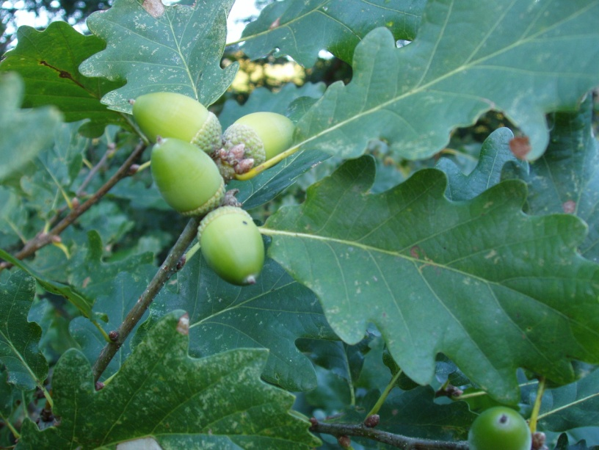
Argoed Community Council
3rd April 2023

The next meeting of Argoed Community Council will take place on Monday, 17th April 2023 at 7:00 pm at Markham Miners’ Welfare
Agenda
- To record attendees and to receive apologies.
- To receive a report from Gwent Police
- To receive a report from the County Councillor for Argoed, Cllr Walter Williams.
- To receive and confirm the minutes of the meeting held on 20th March 2023
- Matters arising from the minutes.
- Correspondence.
- To receive the Clerk/R.F.O’s report and financial statement
- To receive a report from Cllr. John Mullen regarding the Caerphilly County Borough Council 2nd replacement Local Development Plan up to 2035
- To receive a report from Cllr. John Mullen regarding Blackwood Comprehensive School.
- To receive an update on the Council’s Facebook page.
- To receive reports from delegates.
  - Markham Primary School.
  - Argoed Community Hall.
  - Community and Town Councils Liaison Committee.
  - Markham Community House and Leisure Centre.
  - Access Forum
- Local Reports
  - Argoed
  - Hollybush
  - Manmoel
  - Markham
- To receive planning notifications up to 17th April 2023.

Chairman: Community Councillor Walter Williams

