Cyngor Cymuned Argoed
Markham, Argoed,
Manmoel and Hollybush

Clerk/R.F.O. Mrs Cherrie Edwards
9 Gelynos Avenue
Argoed
Blackwood
NP12 0AT
www.argoedcommunitycouncil.org.uk
e-mail: - argoedcc@live.co.uk
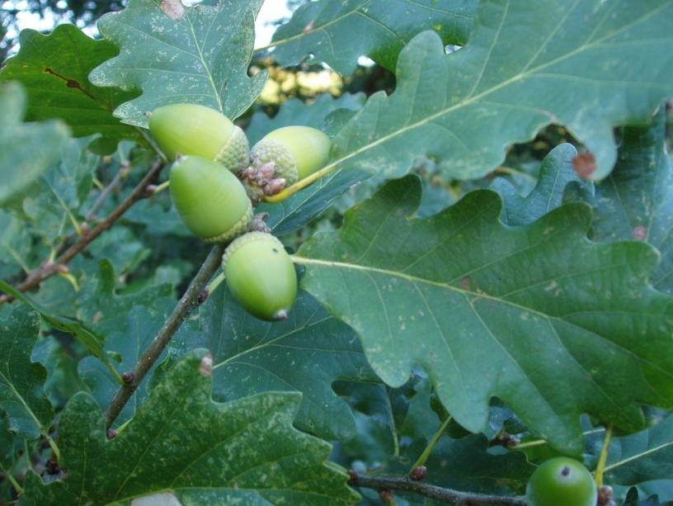
Argoed Community Council
Minutes of Argoed Community Council meeting held on 14th April 2025 held at Markham Miners Institute.
250132 TO RECORD ATTENDEES AND RECEIVE APOLOGIES

Community Councillors Present: Mary Parkes, Emma Williams, Helen Williams and Walter Williams.

Apologies For Absence: Katherine Naylor, Andy Bould and John Mullens.

250133 APPOINTMENT OF NEW CLERK

Cherrie Edwards appointment as new Clerk to Argoed Community Council as of today’s meeting 14/04/2025. The Chair addressed members to discuss salary of new Clerk Cherrie Edwards. Salary was agreed to remain the same until the new increment is advised by Caerphilly County Borough Council.

250134 THE MINUTES OF THE PREVIOUS MEETING HELD ON 17/03/25

Minutes of the meeting held on 17th March 2025 were issued prior to meeting by John Mullens. Minutes were discussed and agreed by committee.
250135 TO RECEIVE A REPORT FROM CLLR WALTER WILLIAMS
Cllr Walter Williams noted the following: -
The Christmas lights opposite Chippy 501 update, Gareth Flemming of Caerphilly County Borough Council has advised there is no lighting column available in the area that is suitable to house the Christmas light. The mini roundabout signage lighting is currently linked to the lamppost, and there is no space available to house the Christmas lighting. Gareth Flemming has queried our indemnity paperwork for our Christmas lighting. Gareth Flemming has recently taken the position in Caerphilly Council and would like clarification on this. Cherrie Edwards to contact Elsbury Access to obtain a copy of our initial instruction of works, should they have this information on file.
Gwent Police now have four new land rovers and a drone to tackle off roading in the local area. Information on the new initiative is one the Gwent Police website and Facebook page.
Cllr Walter Williams will be attending a meeting with countryside is on the 15/4/25 to discuss the wooden steps repair behind Argoed Community Council and an update on any planned repair works.
There are discussions of a raised crossing in Markham to improve the crossing. Looking at £120k to complete the works.
On the 15th August 2025 the British Legion will be holding a VJ Celebration Day at the Cenotaph in Markham. Markham Leisure Centre will be hosting an event to celebrate this day also. Cllr Mary Parkes suggested the Community Council also get involved in celebrating this event. This was agreed by Committee Members. Cllr Walter Williams suggested we order a wreath. Agreed by Committee Members.
Cllr Mary Parkes suggested Markham Playgroup get involved with children making wreaths for the event. This was agreed by Cllr Helen Williams and remaining committee in attendance.
250136 TO RECEIVE A REPORT FROM GWENT POLICE

No Report Received. Cherrie Edwards to contact Jeff Dugmore to introduce herself and request an update for the next meeting.

250137 TO RECEIVE THE CLERKS/R.F.O’S REPORT AND FINANCIAL STATEMENT

John Mullens provided a breakdown of income and expenditures to date. On review of expenditures, it was noted there was incomplete information for 18/09/24 cheque number 0000120. Cherrie Edwards to investigate further and report at next meeting.

250138 TO RECEIVE A REPORT FROM CLLR JOHN MULLENS
Cllr John Mullen has given his apologies for being unable to attend this meeting.

250139 CORRESPONDENCES

Correspondence provided by the Cllr Mary Parkes as received and noted. The required actions were agreed.

250140 To receive an update on the Council’s Facebook page

Cllr Mary Parked noted the following: -

A post is imminent to announce appointment of new clerk and the vacancy for a Argoed ward representative. Will also be advertising the room hire at Markham Miners Institute.

250141 To receive reports from delegates.

250141.1 Markham Primary School.

No meeting since last meeting. Easter bunny visited Markham Primary School last week and gave out 204 easter eggs to children. The outside playroom is also now complete and in use.

250141.2 Argoed Community Hall.

No Report. Cherrie Edwards to contact Stephen Morgan to introduce herself and ask for an update ready for the next meeting.

250141.3 Community and Town Council’s Liaison Committee.

No Report.

250141.4 Markham Community House and Leisure Centre.

Carpark has been relined
Good turnout at the Easter fun day

250141.5 Access Forum

No Report.

250141.6 Markham Playgroup

Was agreed by committee that Helen Williams will provide a report of Markham Playgroup as of today.

Noted that Markham Playgroup has just had an Estyn inspection. Noted that this inspection went well. Report is not ready as yet. But will notify committee one published.

250142 LOCAL REPORTS

250142.1 Argoed ward

No Report.

250142.2 Hollybush ward

No Report.

250142.3 Manmoel ward

No Report.

250142.4 Markham ward

Cllr Walter Williams noted there was an incident outside of the village of a Markham resident, of which was stabbed. This resident has been residing Iin a van At Mountain View of which Cllr Walter Williams has received complaints from residents.

Mattress at the back lane of Bryn Road is causing an obstruction, to which vehicles now have to drive over to access the lane. Cllr Walter Williams will report as fly tipping for its removal.

250143 ANY OTHER BUSINESS

Confirmed the dates for future meetings for the remainder of the year. .Changes to May and July noted below.

12th May 2025 | Markham Miners Institute
19th June 2025 | Manmoel Village Hall
14th July 2025 | Hollybush Community Centre
15th September 2025 | Argoed Village Hall
20th October 2025 | Markham Miners Institute
17th November 2025 | Manmoel Village Hall
15th December 2025 | Hollybush Community Centre

Meeting closed at 8.45pm.

Signed…………………………Chairman of Argoed Community Council

