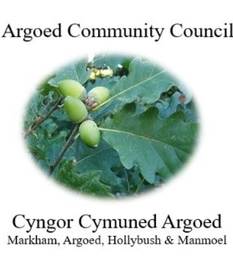
Cherrie Edwards (Clerk)
Argoed Community Council
Hazelhurst Houser
9 Gelynos Avenue
Argoed
Blackwood
Np12 0at

E-mail: argoedcc@live.co.uk
Website: www. argoedcommunitycouncil.org.uk
Telephone: 07904 058935 / 074863228331

The next meeting of Argoed Community Council will take place on Monday 12th May at Markham Miners Institute at 7:00pm.

Agenda

250144 To record attendees and to receive apologies.
250145 To receive and confirm the minutes of the meeting held on 14th April 2025
250146 Matters Arising from the Minutes.

250147 To receive a report from Gwent Police.
250148 Correspondence.
250149 To Receive the clerks/ RFO report and financial statement.
250150 Report from the County Councillor for Argoed, Cllr Walter Williams.
250151 Report from Cllr. John Mullen regarding Blackwood Comprehensive.
250152 To receive update from Cllr. Mary Parkes on the Argoed Community Council Facebook page.

250153 - To receive reports from delegates.

1 Markham Primary School.
2 Argoed Community Hall.
3 Community and Town Councils Liaison Committee.
4 Markham Community House and Leisure Centre.
5 Access Forum
6 Markham Playgroup

250154 Local Reports

250154.1 Argoed
250154.2 Hollybush
250154.3 Manmoel
250154.4 Markham

250155 Any Other Business

Chairman: Community Councillor Mary Parkes

