Cyngor Cymuned Argoed
Markham, Argoed,
Manmoel and Hollybush

Clerk/R.F.O. Mrs Cherrie Edwards
9 Gelynos Avenue
Argoed
Blackwood
NP12 0AT
www.argoedcommunitycouncil.org.uk
e-mail: - argoedcc@live.co.uk
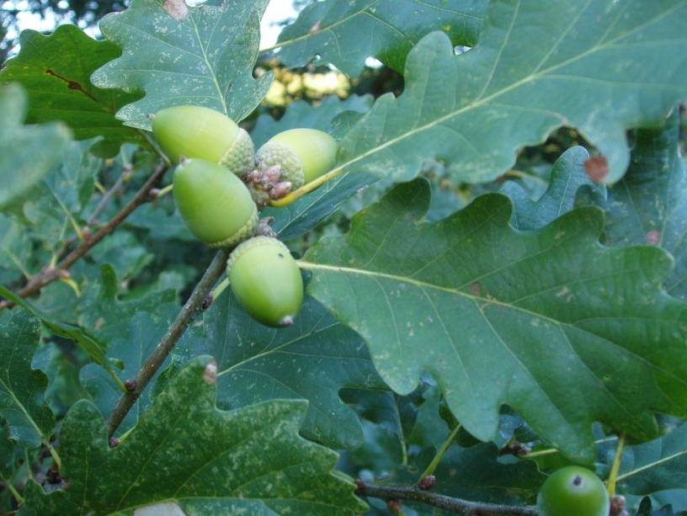
Argoed Community Council
Minutes of Argoed Community Council meeting held on 12th May 2025 held at Markham Miners Institute. AGM meeting has now been postponed until the next scheduled meeting in June.
250144 TO RECORD ATTENDEES AND RECEIVE APOLOGIES

Community Councillors Present: Mary Parkes, John Mullen and Katherine Naylor

Apologies For Absence: Emma Williams, Helen Williams, Walter Williams and Andy Bould

250145 THE MINUTES OF THE PREVIOUS MEETING HELD ON 14/04/25

Minutes of the meeting held on 14th March 2025 were issued prior to meeting by Cherrie Edwards. Minutes were discussed and agreed by committee.

250146 MATTERS ARISING FROM THE MINUTES

To receive update in relation to Christmas lights from Walter Williams at next meeting. Cherrie to add to agenda.

250147 TO RECEIVE A REPORT FROM CLLR WALTER WILLIAMS
No Report.
250148 TO RECEIVE A REPORT FROM GWENT POLICE

Cherrie Edwards contacted Jeff Dugmore to introduce herself and request an update for the next meeting. Jeff advised he is retiring and does not have any information on whom will be taking over his role. Cherrie to contact Gwent Police in several weeks’ time for an update on whom has taken over this role, and any report.

250149 TO RECEIVE THE CLERKS/R.F.O’S REPORT AND FINANCIAL STATEMENT

Cherrie Edwards provided a breakdown of income and expenditures to date. Cherrie confirmed that first half of this year’s precept has been received. Second half of precept is due in September 2025.

Awaiting on approvals for access to the online banking. Cllr Mary Parkes suggested we look into adding on online banking access in order to make payments online. This was agreed with the committee and will be looked into once Cherrie has access.

Discussed balance. Balance looks healthy, Cherrie to produce a forecast of spend in readiness for next meeting. If balance allows, we could look into additional Christmas lights and donations.

250150 TO RECEIVE A REPORT FROM CLLR JOHN MULLEN ON BLACKWOOD COMPREHENSIVE SCHOOL
Cllr John Mullen attended a governor meeting recently. The issue of cleaning was discussed in relation to the recent increase in costs advised by CCBC. John explained that it was noted that the dramatic increase in cleaning costs would cause a deficit for the school. On discussion with CCBC it has been agreed they will look at revising the costs and upgrade their cleaning equipment. At present there will be no loss of any cleaning staff. Awaiting a revised costing from CCBC on cleaning charges.

School have planned an educational trip to Berlin for years 10 and 11 pupils to study German history. This was approved by governors.

There was a discussion on RADY pupils and the progress the school has seen on the attendance of these pupils. Attendance has increased to date.

Holiday absence has been affecting attendance. School has stipulated that parents must contact the school to discuss absence prior to booking holidays. At present parents are booking without discussing with the school.

Markham bus is run by 1st call travel, John has spoken to 1st call and the school in regards to supporting extra-curricular activities, late finishes at school and transporting pupil’s home. There have been several instances where pupils have been unable to get home. 1st call travel has advised that school are able to request later collection time, or wait at site for pupils whom are late with prior notice.

There was a request for the governors of secondary schools to be present on primary school governing bodies to enable a working partnership for primary and secondary school and the transition of pupils into year 7. It was noted that the admissions for this year are down by 25 pupils at present, this could be due to a number of factors including low birth rate in that year and possibly the changes of Lewis School Pengam, that will now see both male and female students onsite together.

250151 CORRESPONDENCES

Correspondence provided - remittance of precept first payment of £7332.36 received.

250152 To receive an update on the Council’s Facebook page

Cllr Mary Parkes has updated the Facebook page recently. Noted messages of condolences for families. A congratulations to Emma for Disability Nurse of the year for 2025.

Updates to Facebook page will be done regularly, it is a great communication tool.

Mary stated that if anyone would like an posts to be added to the page to let her know.

250153 To receive reports from delegates.

250153.1 Markham Primary School.

School is now running an after-school darts club and gardening club.

Cllr Mullen recently attended the school to help with pupils in year 1 who were undertaking a task on famous people. Children undertook work on Gerwyn Price and the darts with support of John’s knowledge.

Cllr Mary Parkes recently attended the school to distribute easter eggs which was a huge success, planning is now underway to replicate this at Christmas with selection boxes for the children.

Head Mistress Lindsey Pritchard is now looking after St James Primary School as acting head alongside her role as head mistress at Markham Primary School.

250153.2 Argoed Community Hall.

Received report from Susan Edwards, Argoed community hall has recently been upgraded with new heating, lighting and decoration. They are now able to host courses, quizzes and talks. They have a large screen, sound system and broadband available.

The welcoming warm spaces project has been running since Nov 22. They have welcomed 605 people over the door between Sept 24 and Mar 25. They offer warm environment with food and drinks and more importantly the opportunity to socialise. This has been achieved through grants from the Welsh Government.

VE day event was successful and saw 45 people attend, who enjoyed music, entertainment and food.

The hall has regular income through its weekly booking of groups who hire the hall.

Forthcoming events are: -
- History of Bedwellty Church on 11th June 2025. Booking details are on the Argoed Community Facebook page

- Voices of 1842. Child Labour talk on 9th July 2025. Booking details are on the Argoed Community Facebook page

250153.3 Community and Town Council’s Liaison Committee.

No Report.

250153.4 Markham Community House and Leisure Centre.

Update from Cllr Mary Parkes, centre is still doing well, with plenty of events underway. They are hosting an afternoon tea and raffle in memory of Robin and Owen Reed. All proceeds will be donated to the family.

250153.5 Access Forum

No Report.

250153.6 Markham Playgroup

No Report.

250154 LOCAL REPORTS

250154.1 Argoed ward

Report from Argoed Community Hall. Detailed above.

250154.2 Hollybush ward

No Report. Cllr Mary Parkes to contact Andy Bould and check in with him.

250154.3 Manmoel ward

Cllr Kath Naylor noted that an Easter tea was held with bingo afterwards, this was very successful event. They also hosted a VE tea party, again was very successful. Donations were asked of residents attended and they managed to cover the cost of the event entirely with additional monies.

The hall has received a new TV.

Concerns regarding the dirt disposal in Manmoel and the effect of the large lorries through the village. There is severe dust produced and the lorries are leaving skid marks on the roads; the roads are becoming in disrepair due to the heavy loads of the lorries. Kath has logged a complained with CCBC in relation to these issues. Cllr John Mullen suggested logging a call with Blaenau Gwent CBC also as the farm in questions lies on Blaenau Gwent boundary and not Caerphilly.

250154.4 Markham ward

Pot holes on Abernant have been repaired. There have been several near misses on this stretch of road from One Stop to Abernant. The bus route is difficult due to parking on this stretch of road.

Near misses at the mini roundabout near the Cenotaph, visibility from Bedwellty and Aberbargoed is limited due to overgrowth.

Youth Darts are representing Wales in Holland shortly. County Darts team are playing Devon at the end of May.

Darts Academy still has a strong uptake from children in the village and wider with people traveling from Cardiff to partake. John is looking to encourage more girls to get involved in darts. John is looking into fund raising to take the children on a day trip during the summer.

250155 ANY OTHER BUSINESS

Cherrie to arrange flowers.
Cherrie to look into when the councilors receive their payments.

Signed…………………………Chairman of Argoed Community Council

