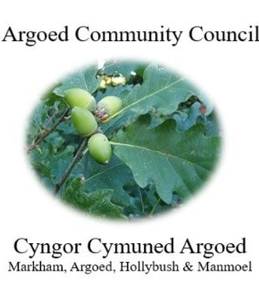
Cherrie Edwards (Clerk)
Argoed Community Council
Hazelhurst Houser
9 Gelynos Avenue
Argoed
Blackwood
Np12 0at

E-mail: argoedcc@live.co.uk
Website: www. argoedcommunitycouncil.org.uk
Telephone: 07904 058935 / 074863228331

Agenda

250156 To record attendees and to receive apologies.
250157 To receive and confirm the minutes of the meeting held on 12th May 2025
250158 Matters Arising from the Minutes.

250159 Annual General Meeting 23rd June 2025.

- To elect a Charmain for year 2025/2026
- To elect a Vice-Charmain for 2025/2026
- To sign declaration of acceptances of office by newly elected charmain
- To elect representatives to serve on the following committees:-
- Markham Primary School
- Any other committees nominated and agreed by AGM

250160 To receive a report from Gwent Police.
250161 Correspondence.
250162 To Receive the clerks/ RFO report and financial statement.
250163 Report from the County Councillor for Argoed, Cllr Walter Williams.
250164 Report from Cllr. John Mullen regarding Blackwood Comprehensive.
250165 To receive update from Cllr. Mary Parkes on Argoed Community Council Facebook page.

250166 - To receive reports from delegates.

1 Markham Primary School.
2 Argoed Community Hall.
3 Community and Town Councils Liaison Committee.
4 Markham Community House and Leisure Centre.
5 Access Forum
6 Markham Playgroup

250167 Local Reports

250167.1 Argoed
250167.2 Hollybush
250167.3 Manmoel
250167.4 Markham

250168 Any Other Business

Chairman: Community Councillor Mary Parkes

