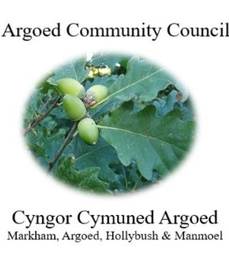
Cherrie Edwards (Clerk)
Argoed Community Council
Hazelhurst Houser
9 Gelynos Avenue
Argoed
Blackwood
Np12 0at

E-mail: argoedcc@live.co.uk
Website: www. argoedcommunitycouncil.org.uk
Telephone: 07904 058935 / 074863228331

Agenda

250182 To record attendees and to receive apologies.
250183 To receive and confirm the minutes of the meeting held on 14th July 2025
250184 Matters Arising from the Minutes.

250185 To receive a report from Gwent Police.
250186 Correspondence.
250187 To Receive the clerks/ RFO report and financial statement.
250188 Report from the County Councillor for Argoed, Cllr Walter Williams.
250189 Report from Cllr. John Mullen regarding Blackwood Comprehensive.
250190 To receive update from Cllr. Mary Parkes on Argoed Community Council Facebook page.

250191 - To receive reports from delegates.

1 Markham Primary School.
2 Argoed Community Hall.
3 Community and Town Councils Liaison Committee.
4 Markham Community House and Leisure Centre.
5 Access Forum
6 Markham Playgroup

250192 Local Reports

250192.1 Argoed
250192.2 Hollybush
250192.3 Manmoel
250192.4 Markham

250193 Any Other Business

Chairman: Community Councillor Mary Parkes

