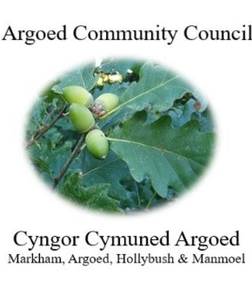
Cherrie Edwards (Clerk)
Argoed Community Council
Hazelhurst House
9 Gelynos Avenue
Argoed
Blackwood
Np12 0at

E-mail: argoedcc@live.co.uk
Website: www. argoedcommunitycouncil.org.uk
Telephone: 07904 058935 / 074863228331

Agenda

250169 To record attendees and to receive apologies.
250170 To receive and confirm the minutes of the meeting held on 14th July 2025
250171 Matters Arising from the Minutes.

250172 To receive a report from Gwent Police.
250173 Correspondence.
250174 To Receive the clerks/ RFO report and financial statement.
250175 Report from the County Councillor for Argoed, Cllr Walter Williams.
250176 Report from Cllr. John Mullen regarding Blackwood Comprehensive.
250177 To receive update from Cllr. Mary Parkes on Argoed Community Council Facebook page.

250178 - To receive reports from delegates.

1 Markham Primary School.
2 Argoed Community Hall.
3 Community and Town Councils Liaison Committee.
4 Markham Community House and Leisure Centre.
5 Access Forum
6 Markham Playgroup

250179 Local Reports

250179.1 Argoed
250179.2 Hollybush
250179.3 Manmoel
250179.4 Markham

250180 Any Other Business

Chairman: Community Councillor Mary Parkes

