Cyngor Cymuned Argoed
Markham, Argoed,
Manmoel and Hollybush

Clerk/R.F.O. Mrs Cherrie Edwards
9 Gelynos Avenue
Argoed
Blackwood
NP12 0AT
www.argoedcommunitycouncil.org.uk
e-mail: - argoedcc@live.co.uk
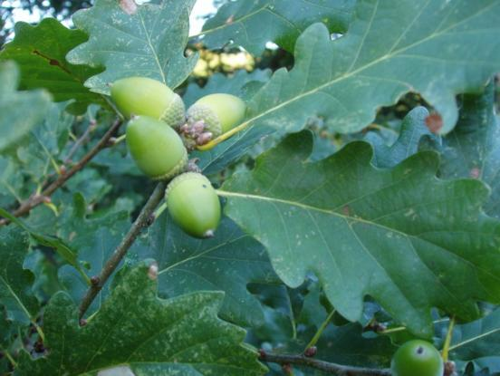
Argoed Community Council
Minutes of Argoed Community Council meeting held on 16th March 2026 at Manmoel Village Hall.
Next Meeting: 20th April 2026 to be held at Hollybush Community Centre at 7:00pm
250243 TO RECORD ATTENDEES AND RECEIVE APOLOGIES

Community Councillors Present: WW, MP, HW, EW, KN
Apologies: CE received apologies from AB & JM.

250244 THE MINUTES OF THE PREVIOUS MEETING

- Minutes agreed by committee.

250245 MATTERS ARISING FROM THE MINUTES

- EW to instruct Williams Bro’s to erect display stand.
- EW queried whether we emailed Bryntirion, CE confirmed.

250246 TO RECEIVE A REPORT FROM GWENT POLICE

No Report. CE to contact Gwent Police to request information on Community officer replacement.

250247 CORRESPONDENCE
- Pre-election guidance, information passed to committee.
- Planning Application – 5 George Street, Argoed. Discussed. No objection.

250248 TO RECEIVE THE CLERKS/R.F.O’S REPORT AND FINANCIAL STATEMENT

CE supplied financial statement, this was reviewed and agreed.

On discussing budget for upcoming financial year, it was agreed by the committee that
a donation of £100.00 was to be given to the community hall’s in each ward.

250249 TO RECEIVE A REPORT FROM CLLR WW
WW will be attending a meeting on Friday 20th March with Rhiannon Passmore and JM. WW will raise the concerns of Bryntirion with RP.
WW will also be attending a meeting with Gwent Police on 31st March. WW will ask for information on the community officer replacement.
Fly tipping still remains a concern across all four villages..

250250 TO RECEIVE A REPORT FROM CLLR JM ON BLACKWOOD COMPREHENSIVE SCHOOL
No Report.
250251 To receive an update on the Council’s Facebook page
MP will update the FB page following the meeting this evening with any relevant information. FB page continues to be updated as and when information comes through.
250252 To receive reports from delegates.

250252.1 Markham Primary School.

The school are holding interviews for a teacher position in April 2026 to start in September 2026.

250252.2 Argoed Community Hall.

Argoed Community Hall are still looking for caretaker.

250252.3 Community and Town Council’s Liaison Committee.

No meeting.

250252.4 Markham Community House and Leisure Centre.

The centre has recently held a Karate tournament, Mother’s Day Afternoon Tea and are starting a choir in the coming weeks.

250252.5 Markham Playgroup

Playgroup is still doing very well. Will be taking on new children in April 2026.

250253 LOCAL REPORTS

250253.1 Argoed ward

No Report.

250253.2 Hollybush ward

No Report.

250253.3 Manmoel ward

Cheese and Wine event was a success. The old public house has sold.

250253.4 Markham ward

MP received donation request from Gemma Baker. CE to email GB the forms to complete.

EW – Stute lights are still on Christmas Tree, CE to contact Elsbury for removal.

20254 ANY OTHER BUSINESS

One Voice Wales have offered free end of year training to Councillors and Clerks; CE has booked herself onto this course.

NEXT MEETING

Next meeting will be held at Hollybush Community Centre on Monday 20th April 2026

Signed…………………………Chairman of Argoed Community Council

FUTURE MEETING DATES - 2026

- 20th April 2026 at 7:00pm - Hollybush Community Centre
- 18th May 2026 at 7:00pm - Argoed Village Hall
- 15th June 2026 at 7:00pm - Markham Miners Institute
- 13th July 2026 at 7:00pm - Manmoel Village Hall
- 21st September 2026 at 7:00pm - Hollybush Community Centre
- 19th October 2026 at 7:00pm - Argoed Village Hall
- 16th November 2026 at 7:00pm - Markham Miners Institute
- 14th December 2026 at 7:00pm - Manmoel Village Hal

