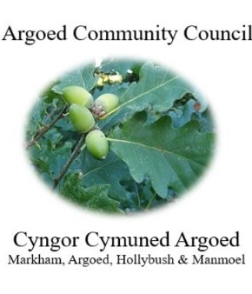
Cherrie Edwards (Clerk)
Argoed Community Council
Hazelhurst House
9 Gelynos Avenue
Argoed
Blackwood
Np12 0at

E-mail: argoedcc@live.co.uk
Website: www. argoedcommunitycouncil.org.uk
Telephone: 07483228331

Agenda

250231 To record attendees and to receive apologies.
250232 To receive and confirm the minutes of the meeting held on 23rd January 2026
250233 Matters Arising from the Minutes.

250234 To receive a report from Gwent Police.
250235 Correspondence.
250236 To Receive the clerks/ RFO report and financial statement.
250237 Report from the County Councilor for Argoed, Cllr Walter Williams.
250238 Report from Cllr. John Mullen regarding Blackwood Comprehensive.
250239 To receive update from Cllr. Mary Parkes on Argoed Community Council Facebook page.

250240 - To receive reports from delegates.

1 Markham Primary School.
2 Argoed Community Hall.
3 Community and Town Councils Liaison Committee.
4 Markham Community House and Leisure Centre.
5 Markham Playgroup

250241 Local Reports

250241.1 Argoed
250241.2 Hollybush
250241.3 Manmoel
250241.4 Markham

250242 Any Other Business

250242.1 Gemma Baker Discuss Penylan Road

Chairman: Community Councillor Mary Parkes

