Cyngor Cymuned Argoed
Markham, Argoed,
Manmoel and Hollybush

Clerk/R.F.O. Mrs Cherrie Edwards
9 Gelynos Avenue
Argoed
Blackwood
NP12 0AT
www.argoedcommunitycouncil.org.uk
e-mail: - argoedcc@live.co.uk
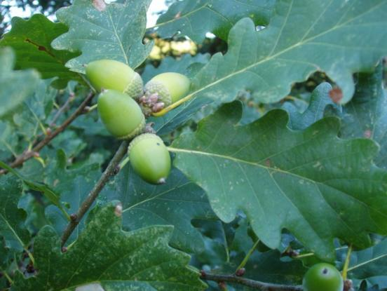
Argoed Community Council
Minutes of Argoed Community Council meeting held on 26th January 2026 at Argoed Village Hall
Next Meeting: 16th February 2026 to be held at Markham Miners Argoed Village Hall at 7:00pm
250219 TO RECORD ATTENDEES AND RECEIVE APOLOGIES

Community Councillors Present: WW, MP, JM, AB, KN
Apologies: CE received apologies from HW, EW

250220 THE MINUTES OF THE PREVIOUS MEETING HELD ON 20/10/2025.

Minutes of the meeting held on 26th January 2026 were issued prior to meeting by CE. Minutes were discussed and agreed by committee.

250221 MATTERS ARISING FROM THE MINUTES

None

250222 TO RECEIVE A REPORT FROM GWENT POLICE

No Report.

250223 CORRESPONDENCE
- Information reviewed from G Baker, CE to chase GO safe.
- Letter from Dean Smith CCBC regarding Speed Concerns reviewed.
- Invoice from Zoey Taylor Wood – Hollybush Defib – agreed. CE to pay.

250224 TO RECEIVE THE CLERKS/R.F.O’S REPORT AND FINANCIAL STATEMENT

Breakdown of expenditure given.

Precept Council Tax increase discussed. Increase of 50p per household agreed by all.

250225 TO RECEIVE A REPORT FROM CLLR WW
Cllr WW attended a budget meeting at CCBC.
Drains blocked in Argoed and Markham, WW has reported to CCBC to have the drains cleared.
Fly tipping is still an ongoing issue with further reports in Argoed and Markham. WW has also reported these to CCBC for clearance.
WW has investigated the hearsay of a HMO at the Druid Inn in Hollybush, CCBC have not received any application to support this at this time.
250226 TO RECEIVE A REPORT FROM CLLR JM ON BLACKWOOD COMPREHENSIVE SCHOOL
Cllr JM was unable to attend the last scheduled meeting, although updated that the Ski trip to Italy was planned for the end of March, with pupils from the wards attending. Will Update the outcome of the experience later this year.
250227 To receive an update on the Council’s Facebook page

Cllr MP is continuing to update the Facebook Page as and when. Still a vital communication tool and point of contact for residents.

250228 To receive reports from delegates.

250228.1 Markham Primary School.

WW & CE reported that the school have invested in a new phonics programme called Monster Phonics, this a new programme being adopted by Cluster Schools. LP reported that they have already seen an improvement children’s willingness to learn, and progress in reading ability. LP will be providing data later this year to show the improvement and progress of the programme.

JM reported that the darts club has now restarted at the school. Fantastic program in helping the children to use their numbers through activity.

MP reported that the children attended a trip to Cardiff University, was an invaluable experience in broaden the children’s future aspirations.

250228.2 Argoed Community Hall.

No Report.

250228.3 Community and Town Council’s Liaison Committee.

No Report. CE to enquire about meeting dates for JM to attend.

250228.4 Markham Community House and Leisure Centre.

WW reported that the centre has just retained its 5* hygiene rating. The centre is now offering more clubs to broaden its offering to the community. Centre is still being well used by the community.

250228.5 Access Forum

No Report. Agreed to remove from Agenda for time being.

250228.6 Markham Playgroup

No Report.

250229 LOCAL REPORTS

250229.1 Argoed ward

No Report.

250229.2 Hollybush ward

WW reported that the room Hire to increase to £35.00 from April 2026. Pathways and vegetation have been cleared in Hollybush by CCBC recently.

The right of way in Hollybush was discussed and confirmed that the right of way proposed for closure was a route this is non accessible at present and will have no impact on the community.

250229.3 Manmoel ward

KN raised the issue of litter in the area, the road conditions due to heavy lorries has caused issues. WW has reported this. There has also been a few break in’s which have been reported to Gwent Police.

KN enquired about the ongoings of Rob Morris plant. WW has enquired about this. Braced bread have announced that they plan to close the Pen-Y-Fan factory site.

KN reported that there has been a few burnt our cars on the mountain leaving a lot of debris. WW queried if it was a CCBC or BG boundary. WW will look into this.

250229.4 Markham ward

JM reported than Jenson Ellaway has again been selected to represent Wales. JM also thanked the Community Council for their £500.00 donation towards equipment for the academy, this has now been spent to replace equipment needed.
JM reported that the visibility at the top roundabout by the Cenotaph is poor again due to overgrowth of vegetation. Fur trees need cutting back.

JM confirmed that the repairs to Abernant Rd and wall have been completed. Still an ongoing issue with traffic on Abernant Rd especially near the shop and pharmacy.

WW confirmed that the roundabout by Chippy 501 is to be addressed this financial year.

WW also informed us that there is a new electric car charging point by the cenotaph, which is already been utilised by the community.

250230 ANY OTHER BUSINESS

Room Hire Charges Discussed. Agreed by all £35.00 charge for all.

NEXT MEETING

Next meeting will be held at Manmoel Village Hall on Monday 16th March 2026

Signed…………………………Chairman of Argoed Community Council

FUTURE MEETING DATES - 2026

- 16th March 2026 at 7:00pm - Manmoel Village Hall
- 20th April 2026 at 7:00pm - Hollybush Community Centre
- 18th May 2026 at 7:00pm - Argoed Village Hall
- 15th June 2026 at 7:00pm - Markham Miners Institute
- 13th July 2026 at 7:00pm - Manmoel Village Hall
- 21st September 2026 at 7:00pm - Hollybush Community Centre
- 19th October 2026 at 7:00pm - Argoed Village Hall
- 16th November 2026 at 7:00pm - Markham Miners Institute
- 14th December 2026 at 7:00pm - Manmoel Village Hal

